**Exploratory Data Analysis Using Data Visualization Techniques**

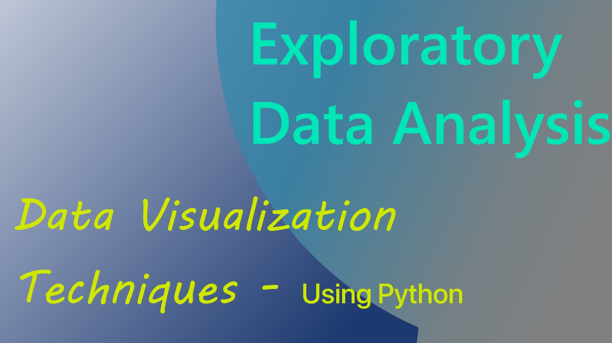

Exploratory Data Analysis or **EDA** refers to the process of analyzing and summarizing datasets to gain insights into the data. This helps in understanding the data and identify patterns, relationships and anomalies.

EDA is a crucial step in any data analysis project. Some of the techniques used in EDA include Python, R, SQL, Excel

The objectives of EDA are to:

* Enable unexpected discoveries in the data
* Suggest hypotheses about the causes of observed phenomena
* Assess assumptions on which statistical inference will be based
* Support the selection of appropriate statistical tools and techniques
* Provide a basis for further data collection through surveys or experiments

To ease more on analyzing data Python is discussed more in details.

**Why Python for EDA?**

* Python is a general yet powerful and versatile programming language widely used in Data Analysis.
* Python is rich in libraries and tools that make it easy to perform the EDA tasks. To mention these libraries are Pandas, NumPy, Matplotlib, Seaborn and Plotly – to be discussed further.
* Python is easy to learn and to be used in EDA tasks hence it is an ideal choice for beginners and experts alike.

**Introduction to Data Visualization**